**Sensor Processing**

1. 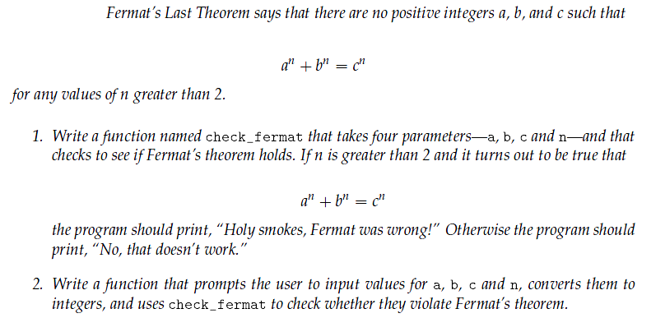Make sure you pay attention to *when* Fermat's Last Theorem applies.
2. The greatest common divisor (GCD) of a and b is the largest number that divides both of them with no remainder. One way to find the GCD of two numbers is based on the observation that if r is the remainder when a is divided by b, then gcd(a, b) = gcd(b, r). As a base case, we can use gcd(a, 0) = a. Write a function called gcd that takes parameters a and b and returns their greatest common divisor.
3. The mathematician Srinivasa Ramanujan found an infinite series that can be used to generate a numerical approximation of 1/ $π$:

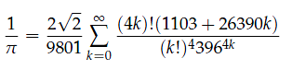

Write a function called estimate_pi that uses this formula to compute and return an estimate of π

1. Get a copy of [sensor.py](http://web.engr.oregonstate.edu/~smartw/me499/labs/lab2/code/sensor.py) and [null_filter.py](http://web.engr.oregonstate.edu/~smartw/me499/labs/lab2/code/null_filter.py). Read them, and make sure you understand what they're doing. Generate a file of (simulated) sensor data, and plot it with Gnuplot. Notice that it's noisy.
2. Write a new filter that replaces each sensor reading with the mean of itself and the readings on either side of itself. For example, if you have these measurements in the middle of the list

10 13 13

then the middle reading would be replace by 12 (since (10 + 13 + 13) / 3 = 12). Generate two files, one for the data before filtering, and one for the filtered data. Plot both of these on the same graph in Gnuplot.

1. Modify your code to have a variable filter width. Instead of a width of 3, add a parameter to the filter function that specifies the filter width. Test this with a variety of widths, and see what it does to the data.
2. Write a variable-width median filter. This is like the mean filter that you just wrote, except that it replaces the values with the *median* of the values, rather than the mean.
3. Write a function that calculates the statistics of the data, and prints them out. You should print the number of data points, the mean measurement, standard deviation, median measurement, the maximum and minimum measurements, and what percentage of measurements are more than one standard deviations from the mean.